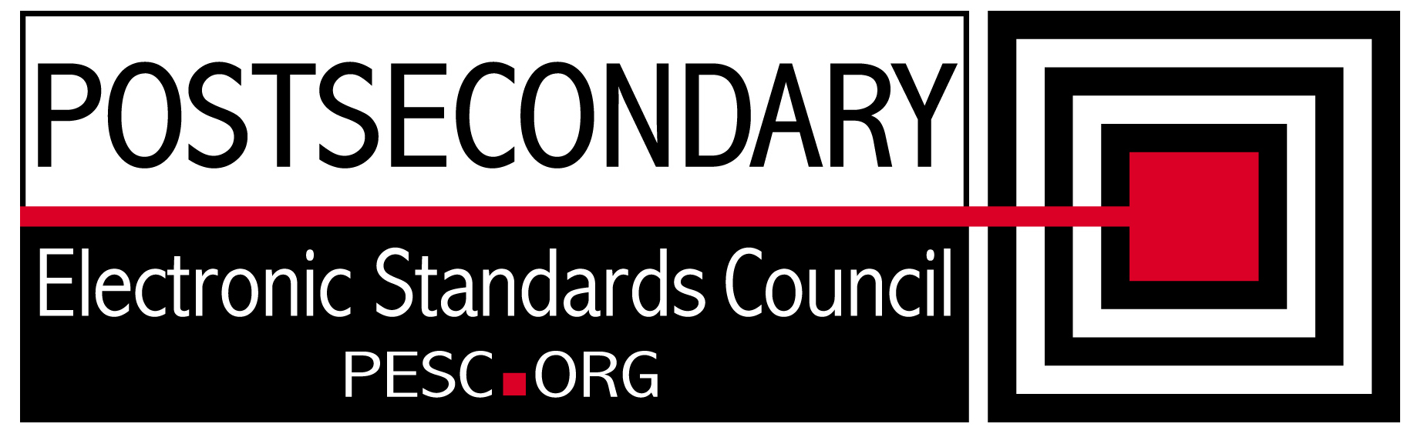

Standards Forum for Education
Status Update Form

Workgroup/Board/Group Name: | Technical Advisory Board
General Summary of Status: | Developed plan for single file schema and for consistency of edu1world PESC community.
Status Flag (Red, Yellow, or Green): | Green
Report Date: | 11/12/2010
Projected Completion Date: | Standing Board
Item | Responsible Resource | Status
Planned Deliverables/Objectives:  - Component Architecture Approach  - Edu1world organization  - Technical Approach to incorporation of CDS  - SIF Architectural Synchronization | Team  Team  Team  Team | Developed consensus on single file schema approach  Evaluated features of system and decided on approach for use. Recommendation forthcoming  On hold until CDS Implementation team mission is clearly defined  On hold until CDS approach defined
Accomplishments/Completions:
- Developed recommendation for Single File Schema approach
- Decided on approach for use of edu1world for PESC.

Issues/Obstacles:

Assistance Needed:
Chair(s)/Leader(s) Name(s): | Gideon Sanstra, Michael Morris
Meetings/Calls Since Last Update: | 4

Note: Chairs and/or leaders of workgroups, boards and committees under The Standards Forum for Education are required to provide updates during the Steering Committee’s monthly conference call meeting held the second Friday each month at 2:00pm EST. Call in information is: 866-352-3799 *7696363*. Forms must be completed and submitted prior to meeting time. Forms may also be posted on the PESC website as needed to provide the community at-large with a means to obtain updates for ongoing, but yet to-be-completed development efforts.

